A Visual Password Recognition Application Based On the American Sign Language

¹Cory Shirts, ²Kevin Ellsworth, ³Wei Dang
Department of Electrical and Computer Engineering
Brigham Young University
Provo, Utah, 84604, USA
¹c.shirts@gmail.com, ²Kellsworth1010@gmail.com, ³weidang@et.byu.edu

Abstract – Developing sign language applications for deaf people can be very important, as many of them, being not able to speak a language, are also not able to read or write a spoken language. Ideally, a translation system would make it possible to communicate with deaf people. In this project, we attempt to create a visual application that reads American Sign Language (ASL)
Keywords – Visual authentication, American sign language recognition, marker, OpenCV
I. Introduction
This is an introduction to our project. Objective, approach, and GUI.

II. SIMILAR WORK
Give a little review of what other people have done so far. What are their approaches (algorithms, tools, speed, accuracy).
III. Opencv LIBRARY
A quick overview of what OpenCV is capable of.

IV. Procedure
In this section we will describe the development of our approach to completing the project. We will first describe the user interface that was developed. Next we will discuss our initial attempts to recognize sign language characters along with the problems we encountered, and our final algorithm.

A. Resources

Our platform consists of a common webcam that captures a 640x480 pixel image. Development was done on laptops with OpenCV-2.1 installed. All development was done using C++.

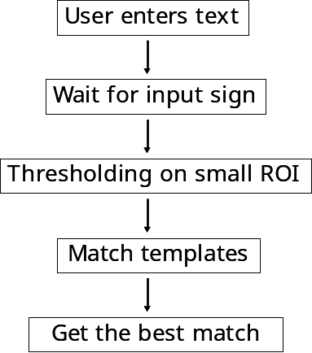

Figure 1

B. Graphic User Interface

The presence of a graphical user interface (GUI) for other projects this semester has proved invaluable for testing and development. Easy methods for gathering test images to develop an algorithm and the need for various visual debug features necessitated the development of our own GUI for this project. The aim of this GUI was not to be a final product, but more of a debug and development environment to aid in the progression of our algorithm.

We started the GUI reusing some of the code used in previous team projects. The portion of code that proved to be the most useful was the portion that controlled the display of the image data captured by the camera. Controls to enter text to prompt the user to sign and other controls to handle the collection of test data were then added.

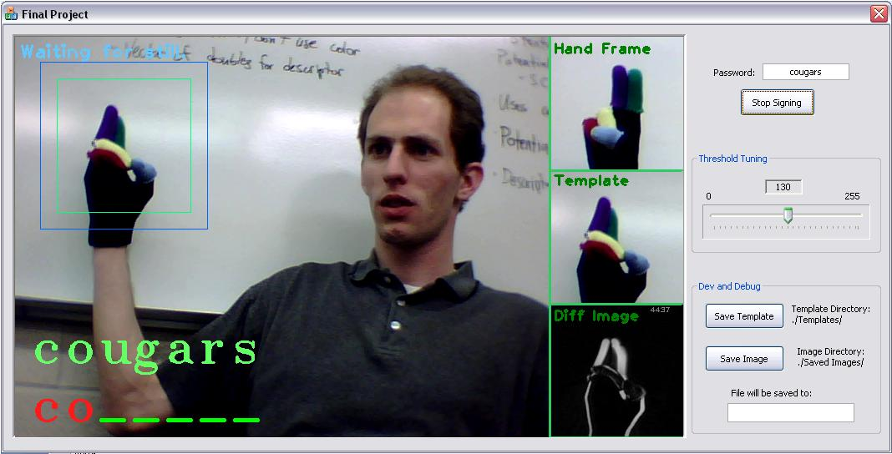
Figure 2 – The final working version of the GUI

Visual debug windows, as shown in Figure 2, are shown to the right of the captured image. To make this portion work was a challenge, for the model code provided from earlier project was custom fit for a normal sized image. These debug windows needed to be drawn onto the bigger display pixel by pixel. Further development would allow us to take advantage of more efficient OpenCV functionality.

One thing that we added to the GUI that was different from the previous projects is how the images are captured from the camera. The code that we were provided captured images continuously in a loop inside another thread as cameras provided them. We replaced this with a timer to capture an image about every 30 milliseconds to give us a more predictable frame rate.

C. User Input

Figure 1 describes the process the program goes through to get input from the user. After the user has entered text and indicated that it is time to sign, we detect motion on a small ROI where the hand is supposed to be making the sign. This ensures that we only start looking for a sign when the user is ready.

Then after a moment of stillness, we capture a frame and find the best match from all of the templates we took using the GUI. The result is printed to the screen and we start the process again by waiting for motion, repeating the process until the user is done entering text.

Figure 3 shows and early example of a template that we used. We compare the templates against a slightly bigger region using the OpenCV matchTemplates function and return the best fit.


Figure 3 – An early template showing the number 6.

D. Preliminary Attempts
We started out by recognizing gestures with bare hand. Problem is.
Problem of template matching
Problem of shape matching
Glove with color markers

E. Final Algorithm
Describe our final algorithm here including template matching with saturation channel for speed up, context checking, and position distinguishing.

V. RESULTS AND Analysis
How accurate is our approach? And under what circumstance it may fail? What are the possible causes for the failures? How fast is our algorithm?

VI. Future Work
.
References
- MN00056 Protocol Manual, Rev. J, QuickSet International Inc., 2006.
- PC/104+ MSM800BEV User Manual, V1.5, Digital-Logic Inc., 2007.
- PolarRx2/2e User Manual, V2.7, Rev. 1, Septentrio Satellite Navigation Inc., 2008.

